Mission 8 – Actuator

1. **Add Spring Boot Actuator dependency to your application.**

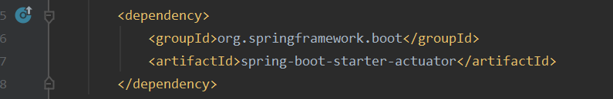

1. **Run your application, verify GET /health endpoint using Postman.**

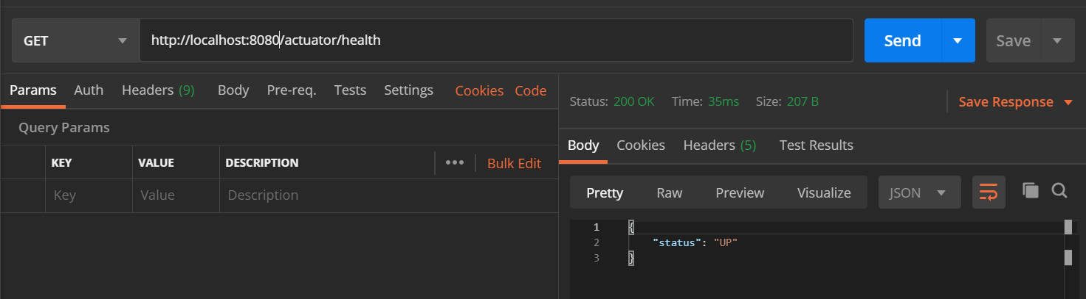

1. **Add @RefreshScope to your Hello World API's controller that uses @Value to retrieve `message` value.**

Codes:

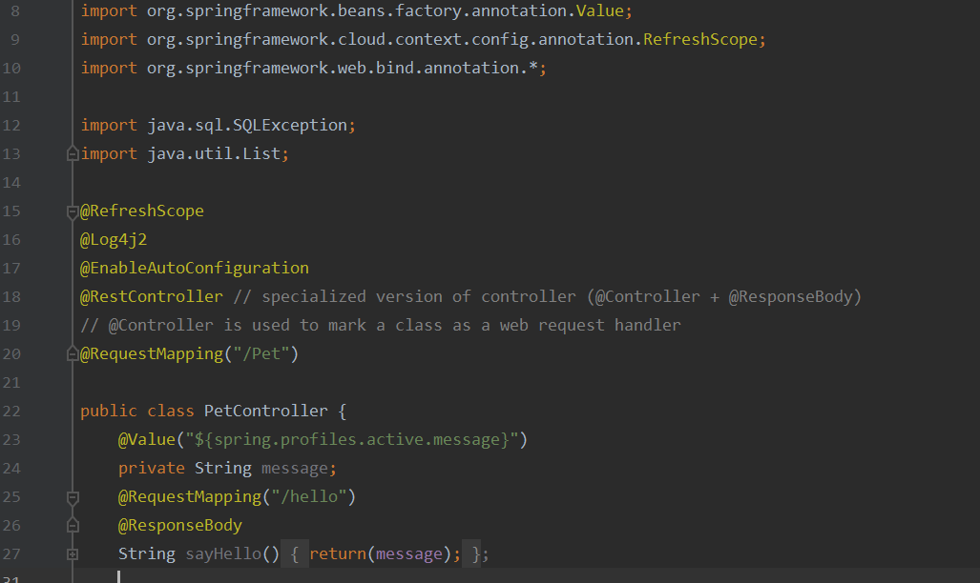

 in application.properties

 in main

Result in postman:

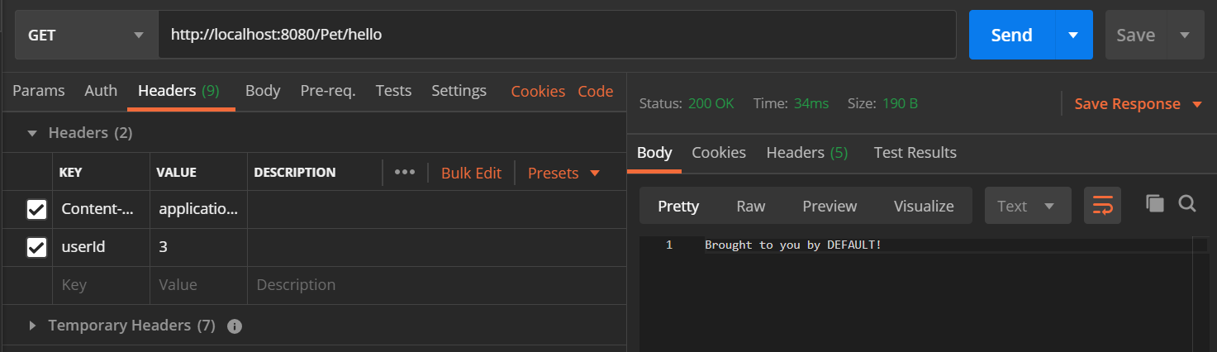

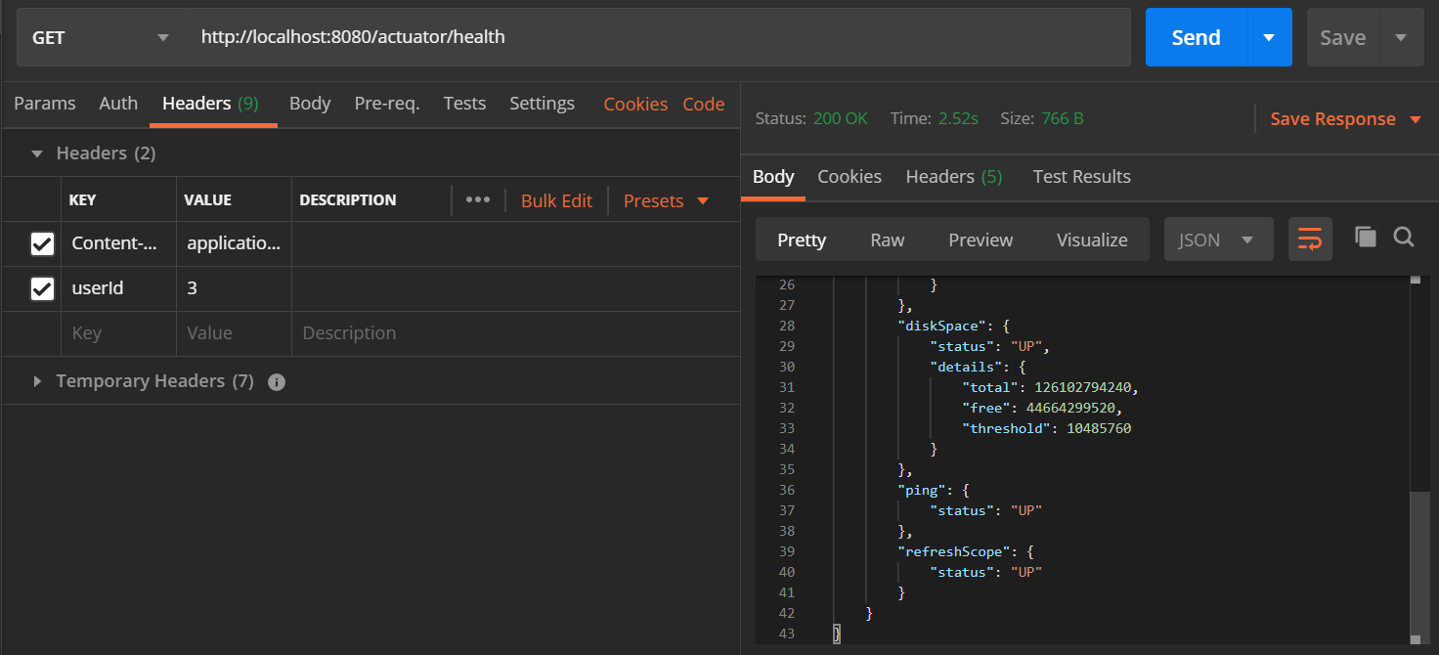

1. **Run your application, use POST /env actuator endpoint to update your `message` value (you might need to call POST /refresh to refresh the configuration change).**
2. **Call your Hello World API and observe the change. If your hello world message does not change, troubleshoot and find out why.**

Result in postman:

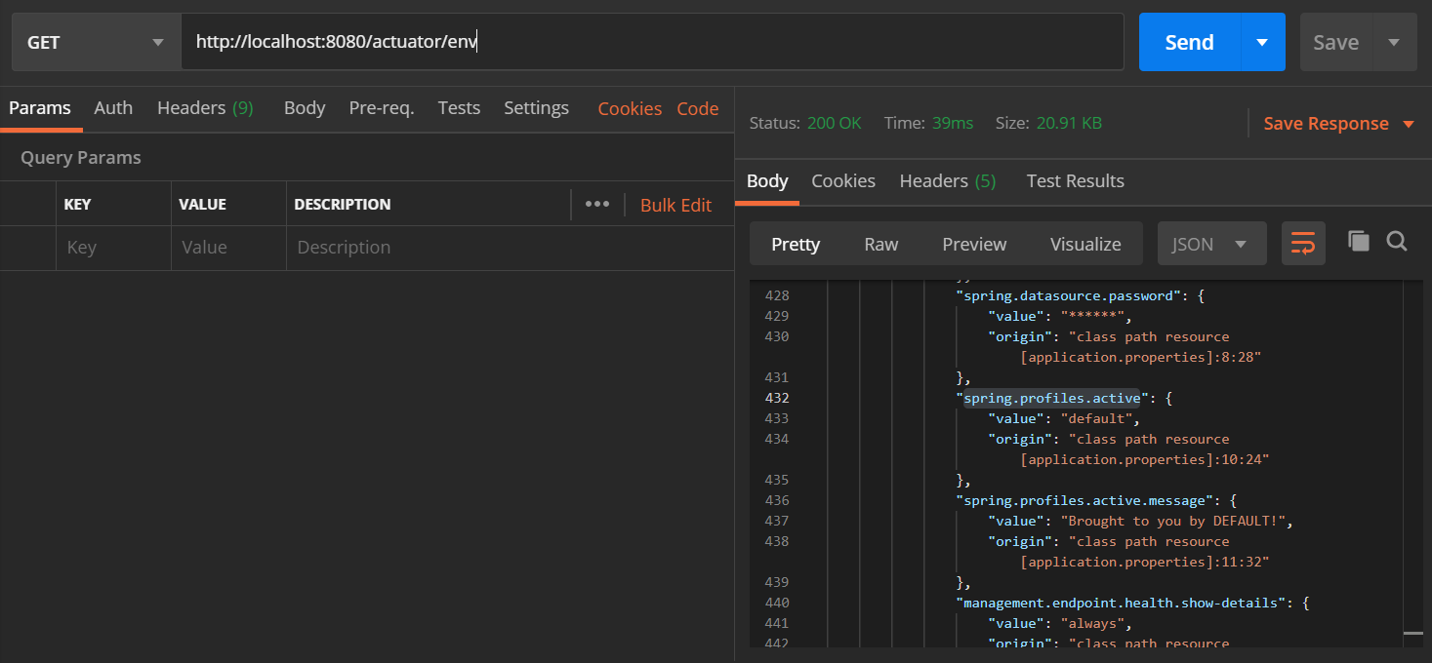

Default result when GET <http://localhost:8080/Pet/hello> request is sent

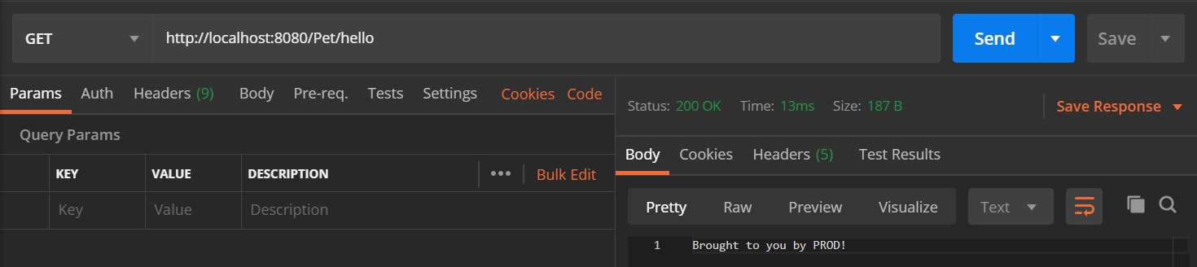

Changing the message to “Test Message”.

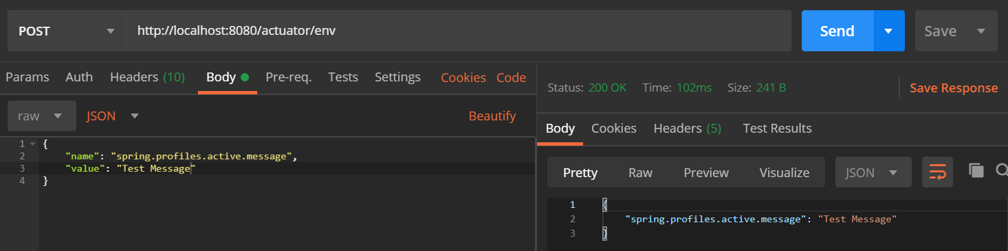

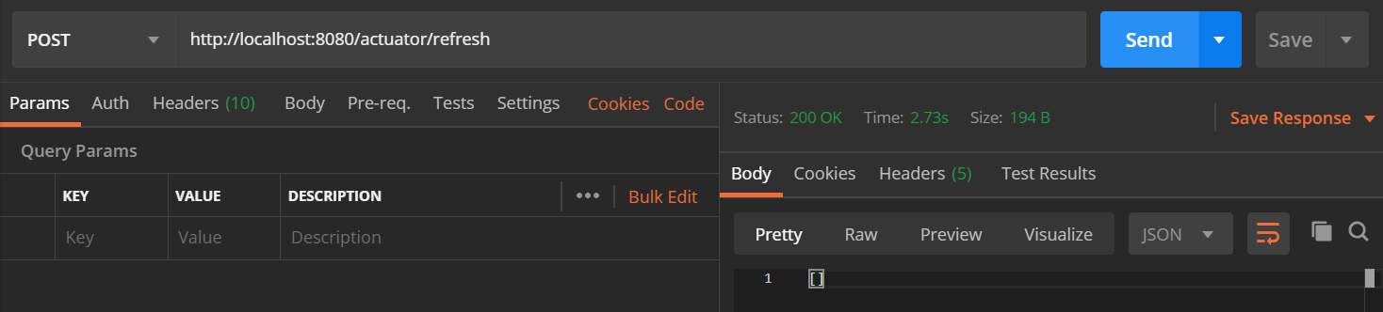

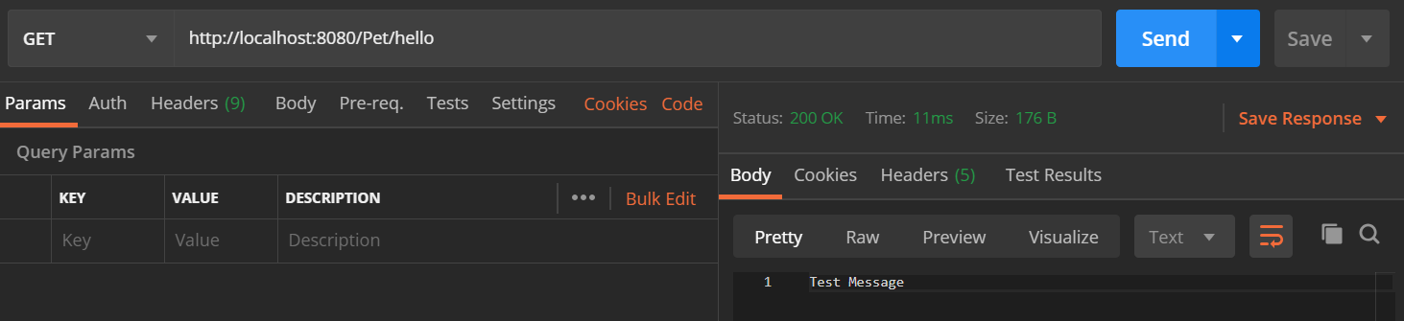

Changing the message to “Brought to you by PROD!”.

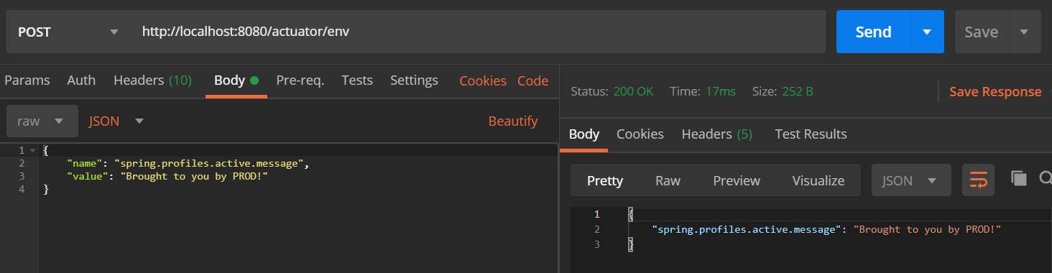

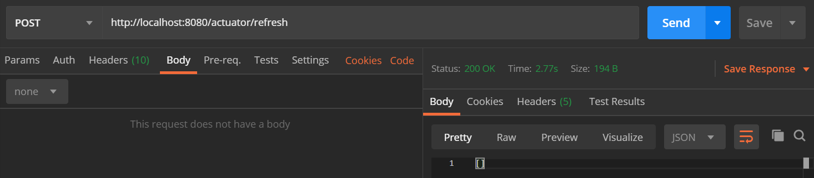

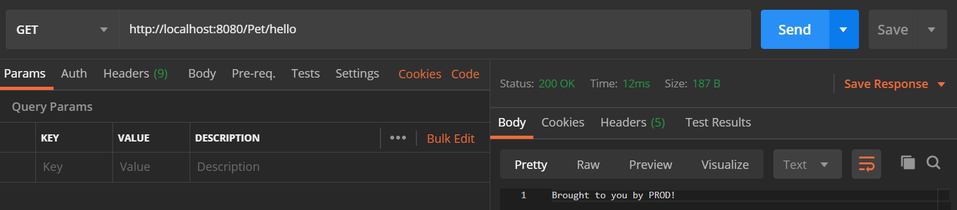

1. **EXTRA - Try creating a custom actuator endpoint using @Endpoint.**

Codes: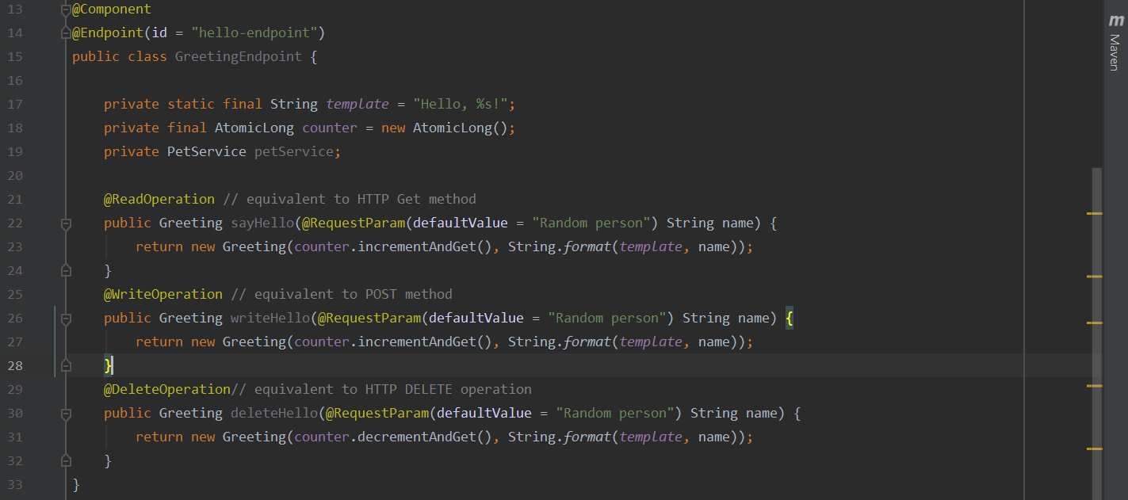

Result in postman:

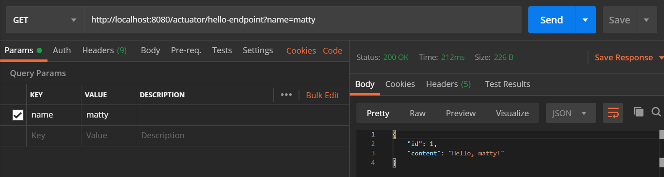 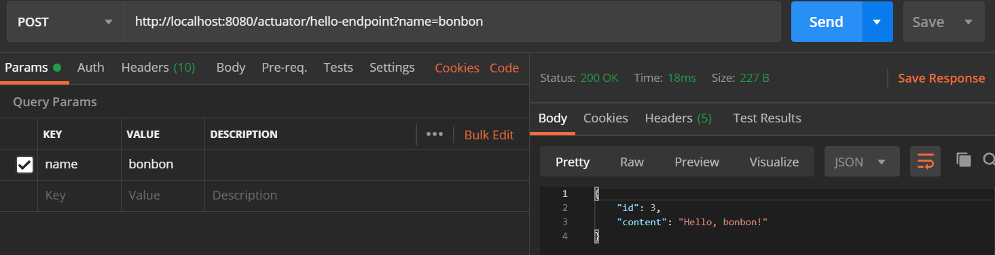 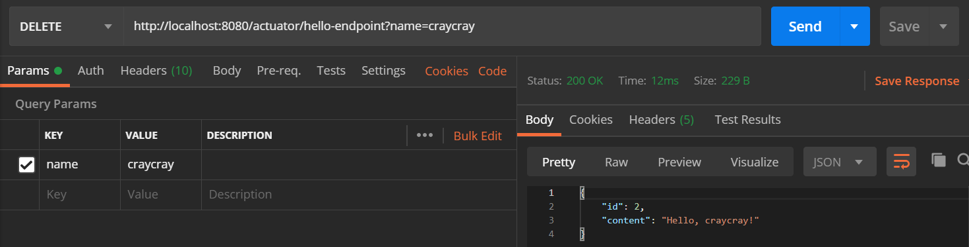

1. **EXTRA - Try creating a custom actuator endpoint using @ControllerEndpoint**

Codes:

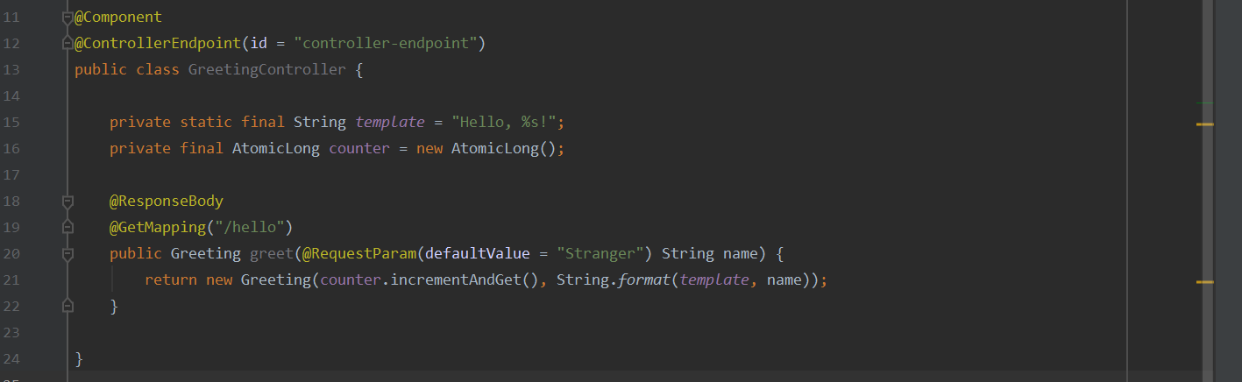

Result in postman:

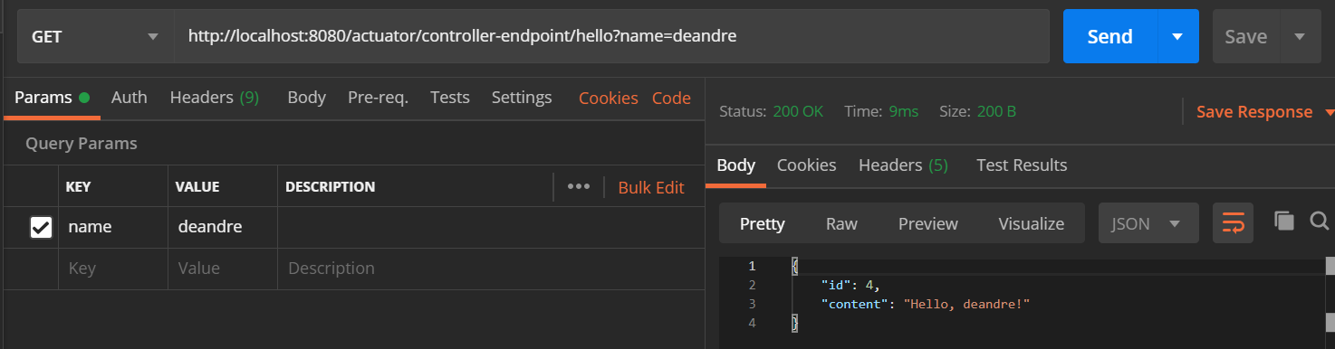

1. **EXTRA - Try creating a custom actuator endpoint using @RestControllerEndpoint**

